**Compilation**

jamess-imac:program AcousticTime$ g++ -c Input.cpp

jamess-imac:program AcousticTime$ g++ -c StringToFloat.cpp

jamess-imac:program AcousticTime$ g++ -c FileCheck.cpp

jamess-imac:program AcousticTime$ g++ -o program4b program4b.cpp Input.o StringToFloat.o FileCheck.o

**Test 1**

jamess-imac:program AcousticTime$ ./program4b

What would you like to do?

Enter 1 to read from file.

Enter 2 to write to file.

Enter 3 to modify a file.

Enter 0 to quit.

Choice: 1

Enter the file name to access: notthere

The filename doesn't exist

What would you like to enter a new filename?

Enter 1 to enter another filename.

Enter 0 to quit.

Choice: 1

Enter the file name to access: test1

1

2

3

4

5

jamess-imac:program AcousticTime$

**Test 2**

jamess-imac:program AcousticTime$ ./program4b

What would you like to do?

Enter 1 to read from file.

Enter 2 to write to file.

Enter 3 to modify a file.

Enter 0 to quit.

Choice: 2

Enter the file name to access: test2

The filename already exists

What would you like to enter a new filename?

Enter 1 to enter another filename.

Enter 0 to quit.

Choice: 1

Enter the file name to access: test2b

Enter the amount of numbers to write: 5

Enter number 1: 1

Enter number 2: 2

Enter number 3: 3

Enter number 4: 4

Enter number 5: 5

jamess-imac:program AcousticTime$

**Test 3**

jamess-imac:program AcousticTime$ ./program4b

What would you like to do?

Enter 1 to read from file.

Enter 2 to write to file.

Enter 3 to modify a file.

Enter 0 to quit.

Choice: 3

Enter the file name to access: test3

The filename doesn't exist

What would you like to enter a new filename?

Enter 1 to enter another filename.

Enter 0 to quit.

Choice: 0

jamess-imac:program AcousticTime$

**UML Class Diagram**

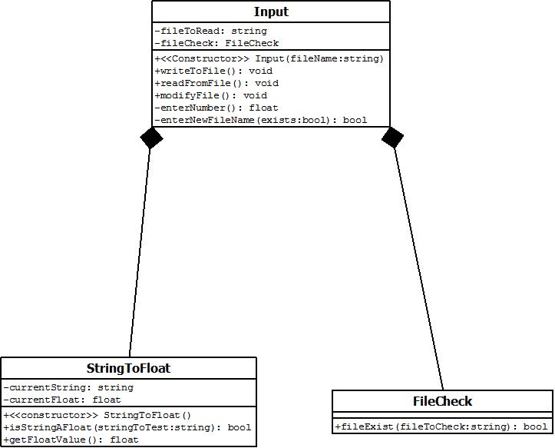

**UML Use Case Diagram**

